GO Math! Kindergarten Chapter Test Alignment
This assessment guidance is designed as a companion to the Go Math K-5 Guidance Documents. It provides support for modifying GO Math! to align to the changes recommended in the Guidance Documents.

The assessment guidance for Kindergarten looks different than other grades given that the evaluation format in this grade is primarily teacher interviews and short tasks. For each chapter, specific diagnostic interview assessment questions from GO Math! along with EngageNY and Illustrative Mathematics tasks have been identified and slightly modified to assess the standards addressed in the chapter. All supplemental resources are hyperlinked in this resource and an accompanying PDF on achievethecore.org has all of the EngageNY assessment tasks in this guide accumulated for the entire grade.

Chapter 1: Represent, Count, and Write Numbers 0 to 5
K.CC.A.3, K.CC.B.4a, K.CC.B.4b

EngageNY:

- Module 1 Mid-Module Assessment Task Topic C (remove last question)

- Module 1 Mid-Module Assessment Task Topic D (remove last 2 questions)

GO Math! Chapter 1 Diagnostic Interview Assessment:

- Explore Numbers

Chapter 2: Compare Numbers to 5
K.CC.C.6

EngageNY:

- Module 3 End-of-Module Assessment Task Topic E (remove first question and modify to 5 spoons and 4 bowls)

- Module 3 End-of-Module Assessment Task Topic F (modify set of 6 linking cubes to be 3 linking cubes, with no set presented that is greater than 5)

Go Math Chapter 2 Diagnostic Interview Assessments:

- One-to-One Correspondence
- Write Numbers 0 to 5

Chapter 3: Represent, Count, and Write Numbers 6 to 9
K.CC.A.3, K.CC.B.5, K.CC.C.6

EngageNY:

- Module 1 End-of-Module Assessment Task Topic E

- Module 1 End-of-Module Assessment Task Topic F

Chapter 4: Represent and Compare Numbers to 10
K.CC.A.3, K.CC.B.5, K.CC.C.6, K.CC.C.7

EngageNY:

- Module 1 End-of-Module Assessment Task Topic G

- Module 1 End-of-Module Assessment Task Topic H

- Module 3 End-of-Module Assessment Task Topic E (remove first question)

- Module 3 End-of-Module Assessment Task Topic F

- Module 3 End-of-Module Assessment Task Topic G

Go Math Chapter 4 Diagnostic Interview Assessments:

- Write Numbers to 9

Chapter 5: Addition
K.OA.A.1, K.OA.A.3, K.OA.A.4, K.OA.A.5

EngageNY:

- Module 4 Mid-Module Assessment Task Topic A (substitute number bond mat for ten frame)

- Module 4 Mid-Module Assessment Task Topic C

- Module 4 End-of-Module Assessment Task Topic E (students should be given the option of using the number bond mat or a ten frame mat)

- Module 4 End-of-Module Assessment Task Topic F

- Module 4 End-of-Module Assessment Task Topic H

Go Math Chapter 5 Diagnostic Interview Assessments:

- More

Chapter 6: Subtraction
K.OA.A.1, K.OA.A.2, K.OA.A.5

EngageNY:

- Module 4 Mid-Module Assessment Task Topic D

- Module 4 End-of-Module Assessment Task Topic G

Go Math Chapter 6 Diagnostic Interview Assessments:

- Fewer

Chapter 7: Represent, Count, and Write 11 to 19
K.NBT.A.1

EngageNY:

- Module 5 Mid-Module Assessment Task Topic A

- Module 5 Mid-Module Assessment Task Topic B

- Module 5 Mid-Module Assessment Task Topic C

Go Math Chapter 7 Diagnostic Interview Assessments:

- Show Amounts to 10
- Write Numbers to 10

Illustrative Mathematics Task:

- Assessing Writing Numbers

Chapter 8: Represent, Count, and Write 20 and Beyond
K.CC.A.1, K.CC.A.2, K.CC.A.3, K.CC.B.5, K.CC.C.6

EngageNY:

- Module 5 End-of-Module Assessment Task Topic D

- Module 5 End-of-Module Assessment Task Topic E

Illustrative Mathematics Task:

- Assessing Counting Sequences Part I

- Assessing Counting Sequences Part II

Chapter 9: Identify and Describe Two-Dimensional Shapes
K.G.A.2, K.G.B.4, K.G.B.6

EngageNY:

- Module 2 End-of-Module Assessment Task Topic A

- Module 2 End-of-Module Assessment Task Topic A (only flat shapes)

- Module 6 End-of-Module Assessment Task Topic B

Go Math Chapter 9 Diagnostic Interview Assessments:

- Shape

Chapter 10: Identify and Describe Three-Dimensional Shapes
K.G.A.1, K.G.A.2, K.G.A.3, K.G.B.4

EngageNY:

- Module 2 End-of-Module Assessment Task Topic B

- Module 2 End-of-Module Assessment Task Topic C (only solid shapes)

- Module 6 End-of-Module Assessment Task Topic A

Chapter 11: Measurement
K.MD.A.1, K.MD.A.2

EngageNY:

- Module 3 Mid-Module Assessment Task Topic A

- Module 3 Mid-Module Assessment Task Topic B

- Module 3 Mid-Module Assessment Task Topic C

- Module 3 Mid-Module Assessment Task Topic D

- Module 3 End-of-Module Assessment Task Topic H

Chapter 12: Classify and Sort Data
K.MD.B.3

EngageNY:

- Module 1 Mid-Module Assessment Task Topic A

- Module 1 Mid-Module Assessment Task Topic B

Appendix of Items: Table of Contents
Chapter 1……………………………………………………………………………………………………………2
- Module 1 Mid-Module Assessment Task Topic C
- Module 1 Mid-Module Assessment Task Topic D
Chapter 2……………………………………………………………………………………………………………8
- Module 3 End-of-Module Assessment Task Topic E
- Module 3 End-of-Module Assessment Task Topic F
Chapter 3……………………………………………………………………………………………………………11
- Module 1 End-of-Module Assessment Task Topic E
- Module 1 End-of-Module Assessment Task Topic F
Chapter 4……………………………………………………………………………………………………………14
- Module 1 End-of-Module Assessment Task Topic G
- Module 1 End-of-Module Assessment Task Topic H
- Module 3 End-of-Module Assessment Task Topic E
- Module 3 End-of-Module Assessment Task Topic F
- Module 3 End-of-Module Assessment Task Topic G
Chapter 5……………………………………………………………………………………………………………21
- Module 4 Mid-Module Assessment Task Topic A
- Module 4 Mid-Module Assessment Task Topic C
- Module 4 End-of-Module Assessment Task Topic E
- Module 4 End-of-Module Assessment Task Topic F
- Module 4 End-of-Module Assessment Task Topic H
Chapter 6……………………………………………………………………………………………………………32
- Module 4 Mid-Module Assessment Task Topic D
- Module 4 End-of-Module Assessment Task Topic G
Chapter 7……………………………………………………………………………………………………………36
- EngageNY Module 5 Mid-Module Assessment Task Topic A
- EngageNY Module 5 Mid-Module Assessment Task Topic B
- EngageNY Module 5 Mid-Module Assessment Task Topic C
Chapter 8……………………………………………………………………………………………………………39
- EngageNY Module 5 End-of-Module Assessment Task Topic D
- EngageNY Module 5 End-of-Module Assessment Task Topic E
Chapter 9……………………………………………………………………………………………………………42
- EngageNY Module 2 End-of-Module Assessment Task Topic A
- EngageNY Module 2 End-of-Module Assessment Task Topic A
- EngageNY Module 6 End-of-Module Assessment Task Topic B
Chapter 10………………………………………………………………………………………………………….48
- EngageNY Module 2 End-of-Module Assessment Task Topic B
- EngageNY Module 2 End-of-Module Assessment Task Topic C
- EngageNY Module 6 End-of-Module Assessment Task Topic A
Chapter 11………………………………………………………………………………………………………….52
- EngageNY Module 3 Mid-Module Assessment Task Topic A
- EngageNY Module 3 Mid-Module Assessment Task Topic B
- EngageNY Module 3 Mid-Module Assessment Task Topic C
- EngageNY Module 3 Mid-Module Assessment Task Topic D
- EngageNY Module 3 End-of-Module Assessment Task Topic H
Chapter 12………………………………………………………………………………………………………….58
- EngageNY Module 1 Mid-Module Assessment Task Topic A
- EngageNY Module 1 Mid-Module Assessment Task Topic B 1

CHAPTER 1






Topic C: Numbers to 5 in Different Configurations, Math Drawings, and Expressions

Rubric Score: Time Elapsed: Materials: (S) 10 linking cubes
T: (Put 5 loose cubes in front of the student.) Whisper-count as you put the cubes into a line. How many cubes are there?
T: (Move the cubes into a circle.) How many cubes are there? T: (Scatter the cubes.) How many cubes are there?
T: Please show this (show 2 + 1) using your cubes. (Have the student explain what she does. We might expect the student to make a linking cube stick of 3 and break it into two parts.)

What did the student do? | What did the student say?

Topic D: The Concept of Zero and Working with Numbers 0–5

Rubric Score: Time Elapsed:

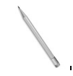
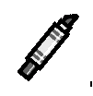

Materials: (S) Sort from Topic B (remove one identical bear for this assessment task so that there are 5 toys and 3 school items), numeral writing sheet

Note: Arrange the pictures as shown to the right. This arrangement is intended to give the student the opportunity to see 5 as 3 and some more, without recounting all.
T: How many things for school do you see? (Point to the top row.)
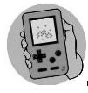
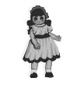
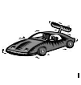
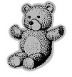
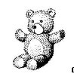
T: (Point to the second row.) These are things we don’t usually bring to school. How many are in this group? (Note if the student recounts all or determines the set of 5 using the set of 3 in any way.) How do you know it is 5?
T: How many cats are shown here?
T: Write your numbers in order from 0 to 5. (Note reversals, if any.) T: Write the number that tells how many toys there are.

What did the student do? | What did the student say?
Did the student show evidence of subitizing or recognizing embedded numbers, seeing 5 as 2 and 3
or 4 and 1?

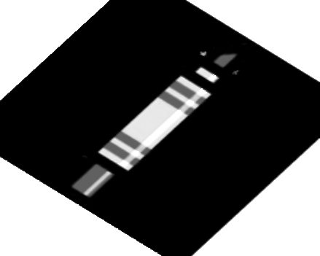

Module 1 Assessment Picture Cards

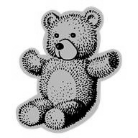 |  | 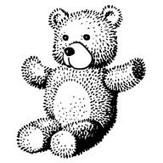
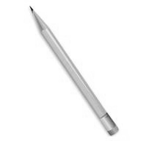 | 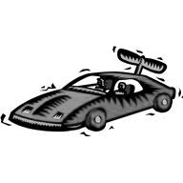 | 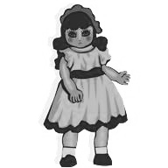
 | 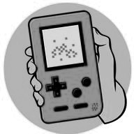

Sorting Mat

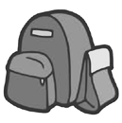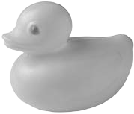

Student Name

Numeral Writing

CHAPTER 2

Student Name

Topic E: Are There Enough?

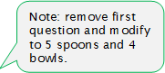
Rubric Score: Time Elapsed:

Materials: (T) 7 spoons, 8 bowls, 6—1 inch × 1 inch squares, 1—2 inch × 3 inch square piece of paper

- Is there enough space on this paper for all these squares? Show me how you know.
- Are there enough spoons for the bowls? Show me how you know.
- Use the words more than to compare the spoons and bowls.
- Use the words less than to compare the spoons and bowls.

What did the student do? | What did the student say?
1.

2.

3.

4.

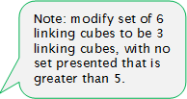
Topic F: Comparison of Sets Within 10

Rubric Score: Time Elapsed:

Materials: (S) 1 set of 6 linking cubes, 1 set of 4 linking cubes, additional linking cubes

- Which set has more cubes? (Show the set of 6 cubes and the set of 4 cubes.)
- Make a set that has the same number of cubes as this one. (Present the set with 4 cubes.) Tell me what you are doing.
- Make a set that has 1 more cube than this set. (Present the set with 6 cubes.)
- Make a set that has 1 less cube than this set. (Present a set with 10 cubes.)

What did the student do? | What did the student say?
1.

2.

3.

4.

CHAPTER 3

Student Name:

Topic E: Working with Numbers 6–8 in Different Configurations

Rubric Score: Time Elapsed:

Materials: (S) 10 linking cubes (or other familiar classroom object)

T: Please count 6 linking cubes, and put them in a row. (Pause.) Write the numeral 6.
T: (Arrange 7 cubes in a circular configuration.) Please count the cubes. (Pause.) Write the number 7.
Show me the 5-group that’s hiding in this group of cubes.
T: (Arrange 8 cubes into an array of 4 and 4.) How many cubes are there now? (Pause.) How did you know there were that many?

What did the student do? | What did the student say?
1.

2.

3.

Topic F: Working with Numbers 9–10 in Different Configurations

Rubric Score: Time Elapsed:

Materials: (S) 12 linking cubes (or other familiar classroom object), brown construction paper mat to show the problem

T: Now, let’s pretend these cubes are bears! Show me this problem: There were six bears who were eating leaves here in the woods. (Pause.) Three more bears came over to snack on some leaves. How many bears were eating leaves in the woods?
T: Use your words to tell me how you figured out the problem.
T: Write the number that tells how many bears there are eating leaves.
T: Another bear came. Show me the bears now. How many bears is that? Write that number.

What did the student do? | What did the student say?
1.

2.

3.

4.

CHAPTER 4

Topic G: One More with Numbers 0–10

Rubric Score: Time Elapsed:

Materials: (T) 5-group cards (Lesson 7 Template, numeral side: 7, 8, and 9), 5-group card (Lesson 7 Template, dot side), 10 cubes

T: (Hold up the card showing 4 dots.) Use the cubes to show me the number of cubes that is 1 more than this.
T: (Hold up the card showing the numeral 7.) Use the number cards to show me the numeral that’s 1 more. How did you learn that?
T: Put these numeral cards in order from smallest to greatest. (Hand the students the 7, 8, and 9 cards out of order.)

What did the student do? | What did the student say?
1.

2.

3.

Topic H: One Less with Numbers 0–10

Rubric Score: Time Elapsed

Materials: (T) 5-group cards (Lesson 7 Template), 10 counting objects
T: (Place 10 objects in an array of two 5-groups.) How many objects are there? (Note how the student counts.) Show 1 less. Write how many you have now.
T: (Put the number cards in order from 10 to 1. Turn over the numbers 9, 7, 5, and 2.) Touch and tell me the hidden numbers. Don’t turn over the cards, though!
T: (Place the 9, 7, 5, and 2 dot cards in a line out of order.) Match the dot cards to the hidden numbers.
Turn over the hidden card when you are sure you have matched it.

What did the student do? | What did the student say?
1.

2.

3.

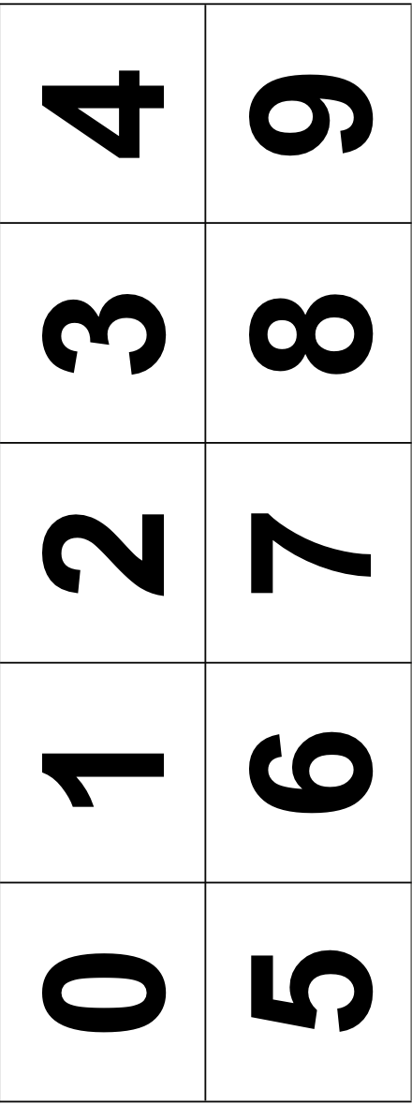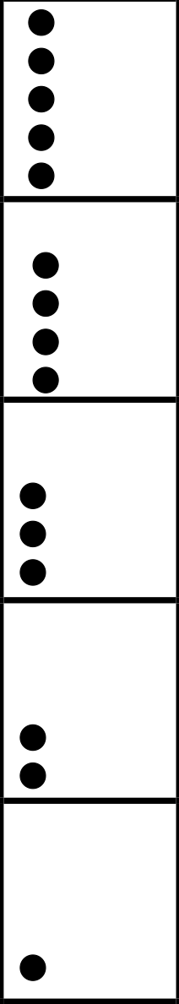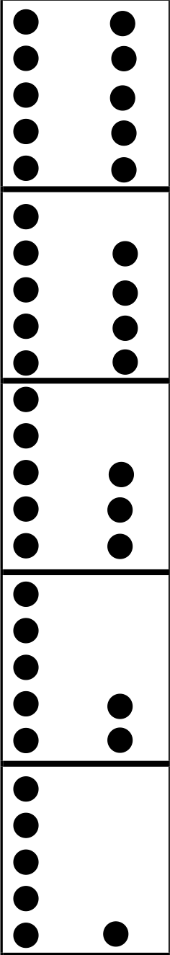

Student Name

Topic E: Are There Enough?

Rubric Score: Time Elapsed:

Materials: (T) 7 spoons, 8 bowls, 6—1 inch × 1 inch squares, 1—2 inch × 3 inch square piece of paper

- Is there enough space on this paper for all these squares? Show me how you know.
- Are there enough spoons for the bowls? Show me how you know.
- Use the words more than to compare the spoons and bowls.
- Use the words less than to compare the spoons and bowls.

What did the student do? | What did the student say?
1.

2.

3.

4.

Materials: (S) 1 set of 6 linking cubes, 1 set of 4 linking cubes, additional linking cubes

- Which set has more cubes? (Show the set of 6 cubes and the set of 4 cubes.)
- Make a set that has the same number of cubes as this one. (Present the set with 4 cubes.) Tell me what you are doing.
- Make a set that has 1 more cube than this set. (Present the set with 6 cubes.)
- Make a set that has 1 less cube than this set. (Present a set with 10 cubes.)

What did the student do? | What did the student say?
1.

2.

3.

4.

Materials: (T) 12 loose linking cubes

- (Present a set with 7 cubes and a set with 5 cubes.) Put these objects in lines to match and compare them.
- Which number is more? Less?
- (Write the numerals 8 and 4.) Use the words more than to compare these two numerals.

What did the student do? | What did the student say?
1.

2.

3.

CHAPTER 5

Student Name

Topic A: Compositions and Decompositions of 2, 3, 4,
and 5
Rubric Score: Time Elapsed: 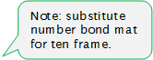 Materials: (S) Number bond mat in a personal white board, tub of loose linking cubes, 4 plastic toy animals

T: (Put 4 toy animals in the whole’s place on the number bond. Orient the whole toward the top.) Tell me a story about part of the animals going here (point to part of the number bond) and part of the animals going here (point to the other part of the number bond). Move the animals as you tell your story.
T: (Turn the number bond mat so that the parts are on top. Put 3 connected linking cubes and 2 connected linking cubes in the parts of the number bond.) Use these linking cubes (present the tub) to complete this number bond. (Students should put 5 linking cubes into the whole’s place.)
T: Replace your cubes with numbers.

What did the student do? | What did the student say?
1.

2.

3.

Topic C: Addition with Totals of 6, 7, and 8

Rubric Score: Time Elapsed:
Materials: (S) Personal white board, story problem Templates 1–3, 10 linking cubes (5 red and 5 blue)

T: (Place Template 1 in front of the student and give him the unconnected linking cubes.) Listen to my story, and watch as I record what I say. Use the cubes to help you remember my story. I had 6 cubes. 2 were red, and 4 were blue. (Write 6 = 2 + 4 on the white board as you talk.) Tell me what the 6 is telling about in my story. Tell me what the 2 is telling about in my story. Tell me what the 4 is telling about in my story.
T: (Place Template 2 in front of the student.) Listen to my story, and use the cubes to help you remember the numbers. There were 5 white puppies and 3 brown puppies in the yard. How many puppies were in the yard? (Write + = on the personal white board.) Write the numbers in the addition sentence that match this story.
T: (Place Template 3 in front of the student.) Listen to my story, and use the cubes to help you remember the numbers. Jacob had 7 toy cars. He puts some on the shelf and the rest in his toy box. How many could be in each place? Write an addition sentence that matches your story.

What did the student do? | What did the student say?
1.

2.

3.



number bond mat

Template 1

Template 2

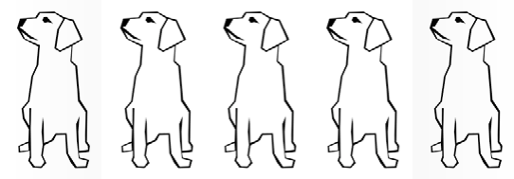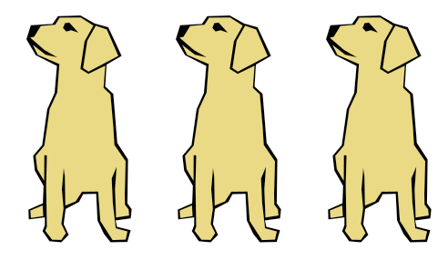

Template 3

Student Name

Topic E: Decompositions of 9 and 10 into Number Pairs

Rubric Score: Time Elapsed: 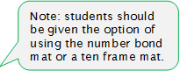 Materials: (S) Personal white board, number bond mat, 10 loose cubes, 2 pieces of construction paper

T: (Put the number bond mat in the personal white board, and write 10 in the whole’s place.) Use your marker to complete this number bond.
T: Anya’s friends brought her 9 presents. They put some of the presents on one table and the rest on the other table. (Place the two pieces of construction paper in front of the student to represent each table.) Use the cubes to show me how Anya’s presents could look. Now, draw a number bond about Anya’s presents.

What did the student do? | What did the student say?
1.

2.

Topic F: Addition with Totals of 9 and 10

Rubric Score: Time Elapsed:
Materials: (S) Personal white board, 9 dots (Template 1), cars (Template 2), flowers (Template 3), 10 linking cubes

T: (Show Template 1 to the student, and write 9 = + on the personal white board.) Look at the 5-group dots. How can the dots help you fill in the blanks of the equation? Fill in the blanks.
T: (Place Template 2 in front of the student.) Listen to my story, and use the cubes to help you remember the numbers. There were 6 orange cars in the parking lot. 4 green cars drove in. How many cars are in the parking lot now? (Write + = on the board.) Write the numbers in the addition sentence to match the story.
T: (Place Template 3 in front of the student.) Listen to my story, and use the cubes to help you remember the numbers. There were 10 flowers. 8 of them were red, and 2 of them were blue. Write an addition sentence that matches this story.

What did the student do? | What did the student say?
1.

2.

3.

Topic H: Patterns with Adding 0 and 1 and Making 10
Rubric Score: Time Elapsed:

Materials: (S) 9 dots (Template 1), number sentences (Template 4), linking cubes, personal white board
T: (Place 5 loose linking cubes of the same color in front of the student.) Count and put the cubes together. How many cubes are there? Take zero cubes away. How many cubes are left? Put zero cubes on your stick. How many cubes are there in all?
T: (Student is still holding his 5-stick from the previous question. Put 5 loose linking cubes of different colors in front of the student.) Put 1 more cube on your stick. How many cubes are there? Put 1 more cube on your stick. How many cubes now?
T: (Place Template 4 in front of the student.) Listen to my story. Hold up the equation that matches my story. 5 fish were swimming in a pond. Then, 3 frogs jumped in the pond. Now, there are 8 animals in the pond. Which equation matches my story?
Listen to some more. There were 8 animals in the pond. The 3 frogs jumped out and went home. Now, there are 5 animals in the pond. Which equation matches my story?
T: (Put Template 1 in front of the student.) How many more does 9 need to be 10? Write an equation that shows how many 9 needs to make 10.
T: (Give the student the personal white board and marker.) Draw the number 7 using a 5-group. How many more does 7 need to make 10? Write an equation that shows how many 7 needs to make 10.

What did the student do? | What did the student say?
1.

2.

3.

4.

5.



number bond mat

Template 1

Template 2



Template 3





Template 4


5 + 3 = 8


8 - 3 = 5

5 - 3 = 2

CHAPTER 6

Topic D: Subtraction from Numbers to 8

Rubric Score: Time Elapsed:

Materials: (S) Personal white board, story problem Templates 2–4, 10 red linking cubes

T: (Place Template 4 in front of the student in the personal white board.) Listen to my story, and watch as I record what I say. Use the cubes to help you remember my story. I had 7 cubes. A boy came and took 2 away. (Cross out 2 cubes and write 7 – 2 = 5 below the cubes.) Tell me what the 7 is telling about in my story. Tell me what the 2 is telling about in my story. Tell me what the 5 is telling about in my story.
T: (Place Template 2 in front of the student.) Listen to my story, and use the cubes to help you remember the numbers. There were 8 puppies in the yard. 5 went into the doghouse. How many puppies were still in the yard? (Write – = on the board.) Write the numbers in the subtraction sentence to match this story.
T: (Place Template 3 in front of the student.) Listen to my story, and use the cubes to help you remember the numbers. Jacob had 7 toy cars. He put 4 cars away in his toy box. How many cars was Jacob still playing with? Write a subtraction sentence that matches this story.

What did the student do? | What did the student say?
1.

2.

3.

Template 2

Template 3

Template 4

Topic G: Subtraction from 9 and 10

Rubric Score: Time Elapsed:

Materials: (S) 10 linking cube stick (5 cubes one color, 5 cubes a different color), 9 crayons, brown paper bag, personal white board, paper, and pencil

T: (Give the student a piece of paper and a pencil.) Listen to my story, and watch what I do. When I’m finished, you are going to record what you hear and see on your paper. You can use a drawing or a subtraction sentence. I have 9 crayons. I’m going to put 1 in this paper bag. How many crayons are left?
T: (Give the student the 10-stick of linking cubes.) How many cubes? Break off some cubes, and put them on the table. How many did you break off? How many are still in your hand? (As the student tells you how many cubes, write – = on the personal white board.) Write the numbers in the blanks that tell what you did with the linking cubes.
T: (Connect the cubes, and erase the board. Place both items in front of the student.) Break off a different number this time, and record your work by writing a subtraction sentence.

What did the student do? | What did the student say?
1.

2.

3.

CHAPTER 7



Student Name

Topic A: Count 10 Ones and Some Ones
Rubric Score Time Elapsed Materials: (S) 19 loose straws (or another set of objects in the
classroom)

T: Count 10 straws into a pile. Whisper while you count so I can hear you. T: Count 6 more straws into a different pile.
T: Count 10 straws and 6 more straws the Say Ten Way. (Pause.) How many straws do you have? (If the student says the number the Say Ten Way, ask the student to also say it the regular way.)

What did the student do? | What did the student say?

Topic B: Compose Numbers 11–20 from 10 Ones and Some Ones; Represent and Write Teen Numbers

Rubric Score Time Elapsed

Materials: (S) 19 cubes, work mat, marker, Hide Zero cards

T: (Show the numeral 13.) Move this many cubes onto your work mat.
T: Use the Hide Zero cards to show the number of cubes on your work mat.
T: Hand me the cubes that the 1 is telling us about. (Point to the 1 of 13 on the numeral 13.) T: (Put 3 more cubes.) This is 16 cubes. Please write the number 16 on your work mat.

What did the student do? | What did the student say?

Topic C: Decompose Numbers 11–20, and Count to Answer “How Many?” Questions in Varied Configurations

Rubric Score Time Elapsed

Materials: (S) 19 cubes

T: (Set out 15 cubes in a scattered configuration.) Count 12 cubes into a straight line. (Pause.) How many cubes are there counting the regular way? The Say Ten Way?
T: Move the cubes into 2 rows.
  - How many cubes are there? (Assessing for conservation.)
  - Please show me how you count these cubes that are now in rows. T: Move the cubes into a circle.
- How many cubes are there? (Assessing for conservation.)
- Please show me how to count these cubes that are now in a circle. T: Put one more cube in your circle. How many cubes do you have now?

What did the student do? | What did the student say?

CHAPTER 8

Student Name

Topic D: Extend the Say Ten and Regular Count Sequence to 100

Rubric Score Time Elapsed Materials: (T) Ten 10-frame cards representing 10
Set out the ten 10-frame cards.
T: (Set out two 10-frame cards.) How many dots are on these cards? Touch and count each dot the regular way. Whisper while you count so I can hear you.
T: Please count the dots from 11 to 20 the Say Ten Way. T: Please count by 10s to 100 the Say Ten Way.
T: Please count by 10s to 100 the regular way.
T: Start at 28. Count up by 1s and stop at 32 the regular way. (If the student is unable to do this, try 8 through 12, then 18 through 22.)

What did the student do? | What did the student say?

Topic E: Represent and Apply Compositions and Decompositions of Teen Numbers

Rubric Score Time Elapsed

Materials: (S) 17 centimeter cubes, 8 ½" × 11" number bond template (Lesson 7 Template) in personal white board, eraser

T: (Set out 17 cubes.) How many cubes are there? (Note the arrangement in which the student counts. If the student does not arrange into a straight line or array, do so for the student.)
T: Separate 10 cubes into a group.
T: Write 17 as a number bond on your personal white board using 10 ones as one of the parts. (Be sure to have students write the numerals.)
T: (Write 17 = + _.) Make an addition sentence to match your number bond. T: How are your number bond and your addition sentence the same?

What did the student do? | What did the student say?

CHAPTER 9

Student Name

Topic A: Two-Dimensional Flat Shapes

Rubric Score: Time Elapsed:

Materials: (S) Paper cutouts of typical triangles, squares, rectangles, hexagons, and circles; paper
cutouts of variant shapes and difficult distracters (see Geometry Progression, p.6)

- (Hold up a rectangle. Use different shapes for each student.) Point to something in this room that is the same shape and use your words to tell me all about it. How do you know they are the same shape?
- (Place several typical, variant, and distracting shapes on the desk. Be sure to include three or four triangles.) Please put all the triangles in my hand. How can you tell they were all triangles?
- (Hold up a rectangle.) How is a triangle different from this rectangle? How is it the same?
- (Place five typical shapes in front of the student.) Put the circle next to the rectangle. Put the square below the hexagon. Put the triangle beside the square.

What did the student do? | What did the student say?
1.

2.

3.

4.

Topic B: Composing and Decomposing Shapes
Rubric Score: Time Elapsed:

Materials: (S) Pattern block shapes, 2 right triangles, paper square cut into 3 pieces (template), puzzle template

- (Give the student two right triangles.) Use these triangles to make a rectangle.
- (Give the student the three-piece paper square puzzle disassembled.) This was a square. Then I cut it into three pieces. Can you put it together so it makes a square again?
- (Place the pattern blocks and puzzle template in front of the student.) Use your pattern blocks to complete the puzzle.

What did the student do? | What did the student say?
1.

2.

3.

Pattern Block Template

Puzzle Templates

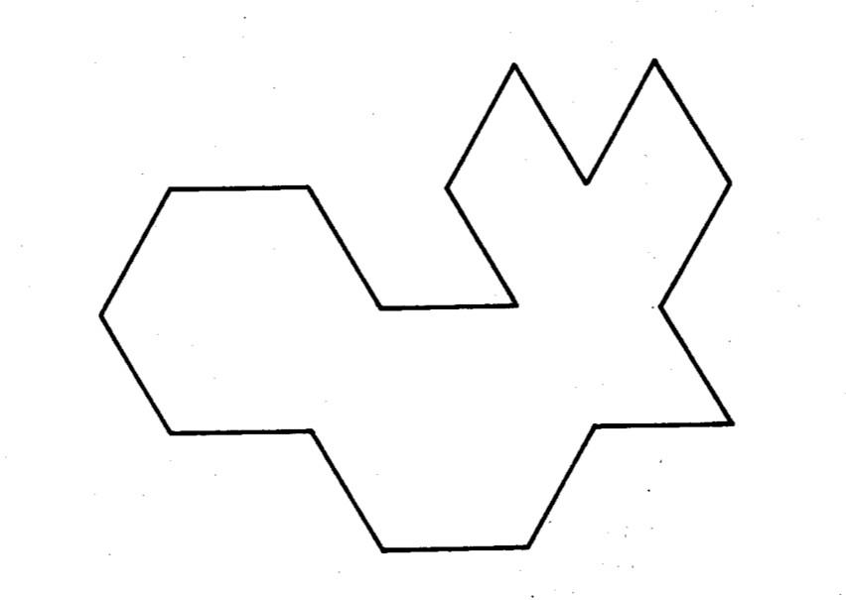

CHAPTER 10

Topic B: Three-Dimensional Solid Shapes

Rubric Score:
Time Elapsed:

Materials: 1 cone; 3 cylinders (wooden or plastic); a variety of real solid shapes, e.g., soup can, paper towel roll, party hat, ball, dice, or an unsharpened cylindrical (not hexagonal prism) pencil

- (Hand a cylinder to the student.) Point to something in this room that is the same solid shape, and use your words to tell me all about it.
- (Place seven solid shapes in front of the student including three cylinders: wooden, plastic, realia.) Put all the cylinders in this box.
- (Show a cone.) How is the cylinder you are holding different from this cone? How is it the same?
- (Place the set of solid shapes in front of the student.) Put the cube in front of the cylinder. Put the sphere behind the cone. Put the cone above the cube.

What did the student do? | What did the student say?
1.

2.

3.

4.

Topic C: Two-Dimensional and Three-Dimensional Shapes

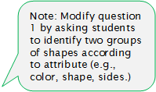
Rubric Score: Time Elapsed:

ather both construction paper,

Materials: Set of flat and solid shapes (do not use the paper cutouts from Topic A, but r commercial flat shapes and classroom flat shapes, such as a piece of colored a CD sleeve, or a name tag)

- Can you sort these shapes into one group of flat shapes and one group of solid shapes?
- Tell me about your groups. What is the same about both groups? What is different?
- Can you sort these shapes a different way? Tell me about your new groups. What is the same? What is different?

What did the student do? | What did the student say?
1.

2.

3.

Student Name

Topic A: Building and Drawing Flat and Solid Shapes

Rubric Score: Time Elapsed:

Materials: (S) 1 set of four 3″ straws, 1 set of four 5″ straws (separated by length for the students), small clay balls for connectors, 5 real world items with familiar shapes (e.g., book, clock, etc., including a square and rectangle), pattern block template

- (Place all straws and formed clay connecting balls in front of the student.) Build a square.
- (Place solid shapes in front of the student.) Choose one object that has the shape you just built.
- (Place pattern block template in front of the student horizontally.) The star is the beginning. Point to the third shape. Point to the seventh shape.
- (Turn the template vertically.) The star is the beginning. Point to the first shape. Point to the ninth shape.

What did the student do? | What did the student say?
1.

2.

3.

4.

CHAPTER 11

Student Name

Topic A: Comparison of Length and Height

Rubric Score: Time Elapsed:

Materials: (S) 6- and 9-inch pieces of string

Cover strings so each string has 3 inches exposed from a piece of paper. Let pieces be parallel to each other.
- Each piece of string is hiding under the paper. Can we tell which one is longer? Why or why not?
- (Uncover them.) Compare this string to this string. Use the words longer than.
- Move the strings so that they line up on one end.
- Compare these strings now. Use the words shorter than.
- When we use the words longer than or shorter than, what are we comparing?

What did the student do? | What did the student say?
1.

2.

3.

4.

5.

Materials: (S) Linking cube sticks of 5 and 7, 9-inch piece of string

- (Present the 5-stick and 7-stick.) Compare the length of these two sticks. Use the words longer than.
- Compare the length of your 5-stick to the length of this string. (Show the 9-inch string from Topic A.) Use the words shorter than.
- Break this 5-stick into two parts. Compare the length of your 5-stick to the length of the two sticks you are holding now.

What did the student do? | What did the student say?
1.

2.

3.

Materials: (S) Balance scale, pennies, centimeter cubes, 1 light book, 1 heavy book

- Compare the weight of this book to the weight of this book. Use the words heavier than.
- Put the scissors and the ruler on the balance scale. Use the words lighter than to compare their weights.
- Use the scale to show how many cubes are the same weight as the marker. How many cubes are the same weight as the marker?
- Use the scale to show how many pennies are the same weight as the marker. How many pennies are the same weight as the marker? Tell me anything else you notice.
- When we use the words lighter than or heavier than, what are we comparing?

What did the student do? | What did the student say?
1.

2.

3.

4.

5.

Topic D: Comparison of Volume

Rubric Score: Time Elapsed:

Materials: 1 small container (⅛ cup), 1 plastic cup with ½ cup of rice in it, 1 small bowl filled with rice, tub for pouring rice from bowl into cup

- Compare the capacity of this bowl and this cup. Use the words more than. (The student may want to pour to assess or will simply observe to make the comparison.)
- How many small containers of rice hold the same amount of rice as this large container? (Watch to see what the student does. Ask the student to use the small container to prove his or her answer if the container is not used without prompting.)
- When we just used the words more than or less than, what were we comparing?

What did the student do? | What did the student say?
1.

2.

3.

Topic H: Clarification of Measurable Attributes

Rubric Score: Time Elapsed:

Materials: (T) Empty juice box with the top cut off, cup, linking cube stick of 7, balance scale, many additional cubes, a tub with the empty juice box full of rice, student scissors

- Compare the length of this juice box to the length of this stick. Use your words.
- Compare the weight of this juice box to the weight of this pair of scissors. Use your words.
- Compare the weight of this juice box to the weight of the cubes. How many cubes weigh the same as the juice box? Use your words. (If the student does not use the balance scale but makes a thoughtful guess, encourage use of the scale to confirm the estimate.)
- Compare the capacity of this juice box to this cup.

What did the student do? | What did the student say?
1.

2.

3.

4.

CHAPTER 12

Student Name:

Topic A: Attributes of Two Related Objects

Rubric Score: Time Elapsed:

Materials: (S) Module 1 assessment picture cards (cut out)

T: (Identify the pictures as you place them in a row before the student.) Show me the pictures that are exactly the same.
T: How are they exactly the same?
T: Show me something that is the same but a little different.
T: Use your words, “They are the same, but…” to tell me how the bears are different.

What did the student do? | What did the student say?

Topic B: Classify to Make Categories and Count

Rubric Score: Time Elapsed:

Materials: (S) Module 1 assessment picture cards (cut out), sorting mat

T: (Place all of the cards before the student.) Please sort the pictures into two groups on your sorting mat. (After sorting, have the student explain her reasoning.)
T: (Point to the objects that went in the backpack.) Count the things that are in this group. (Look for the student to answer “3” rather than “1, 2, 3.” If the student recounts to find the answer, ask again.)
Set the sort aside for the Topic D assessment.

What did the student do? | What did the student say?

Module 1 Assessment Picture Cards

Sorting Mat

Student Name

Numeral Writing

